**Mohammed Al Madhi**

**CIS 480**

**FALL 2020**

**Homework 5 – Cryptography**

|  |
| --- |
| * This is an individual assignment, and is worth 20 points. * The due date is Wednesday, October 7 midnight. * You need to provide your answers using the Outcome file. * Follow the usual naming convention. * Do not make screenshots too small. |

## Task 1 (4 points)

* (1.5 points) Create a histogram for each text that display the relative frequency of letters in a graphical form. For this, go to Analysis > Tools for Analysis. Provide the two histograms in screenshots.

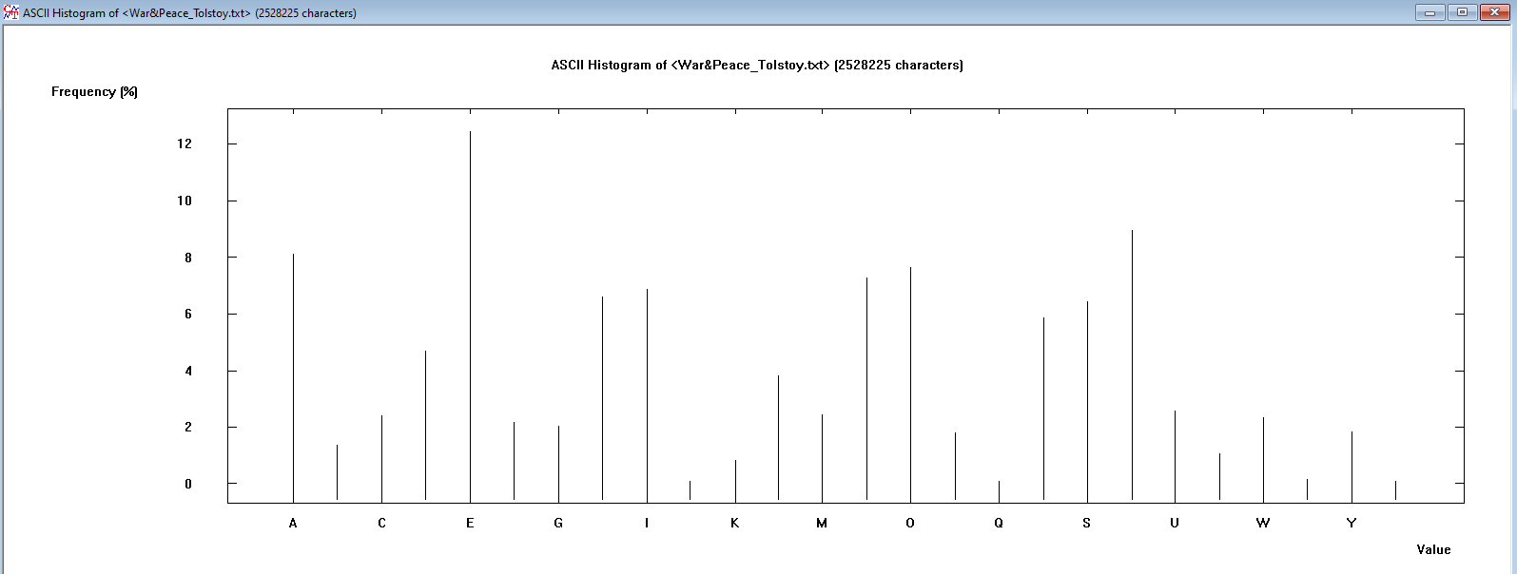

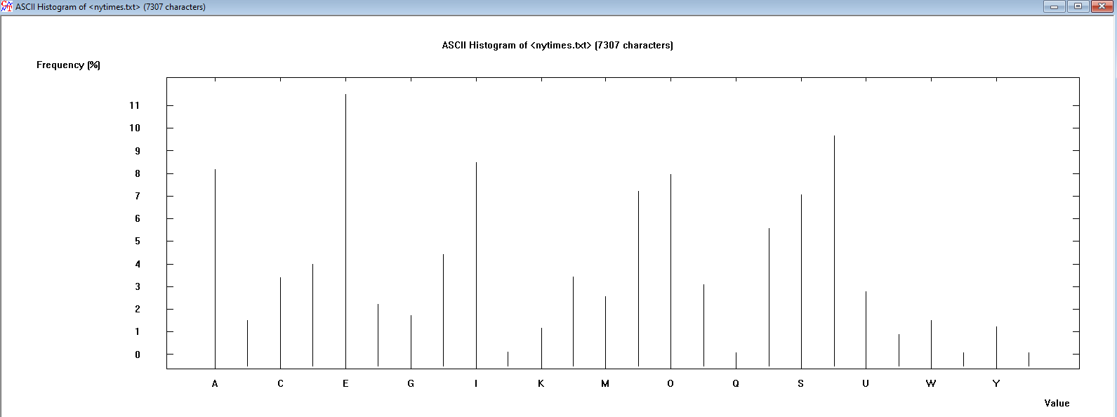

* (1.5 points) Do the two histograms depend significantly on the texts you have provided?

**Yes, a histogram is based on the letters of the texts. Each histogram shows ho many letters are in each text file.**

* (1 point) Calculate the entropy of each text. For this, Analysis > Tools for Analysis > Entropy. What would you conclude from the comparison of the entropies?

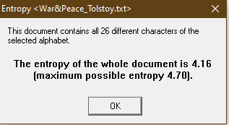

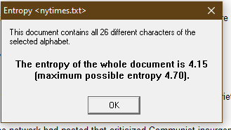

War and Peace has an entropy of 4.16, and the nytimes text file has a 4.15 both text files have the highest entropy possible which means they are unpredictable.

## Task 2 (4 points)

* (2 points) What are the characteristic features of the obtained distribution compared with the original text? Provide a screenshot to support your answer.

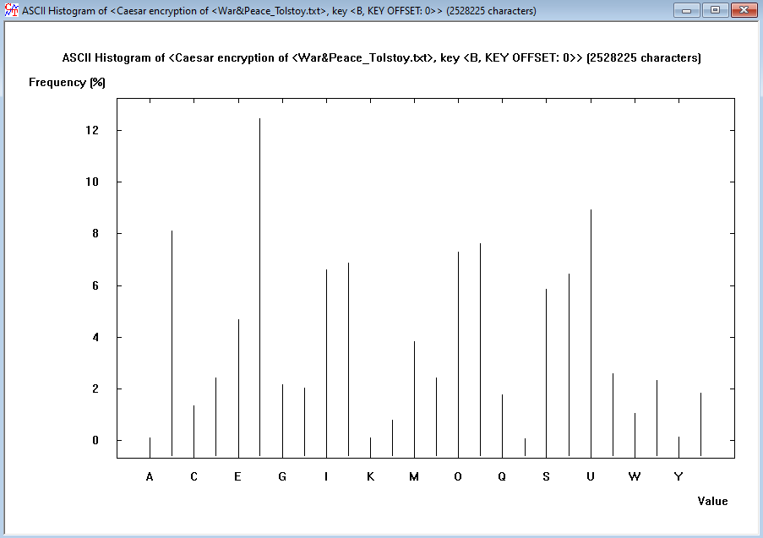

**When comparing both histograms the value of the encrypted histogram has changed because when I encrypted the text, the letters have change for example A becomes B, B becomes C and so on, this happens because I used the Caesar cipher encryption**

* (2 points) How would you apply the features you have discovered in cracking the key?

**If I want to crack the key, I would reverse the letters, for example letter C would be reversed to B, B would be reversed to A.**

## Task 3 (4 points)

* (1.5 points for War&Peace_Tolstoy.txt) Summarize your observation of the frequency distribution. Also, provide a screenshot of the frequency distribution.

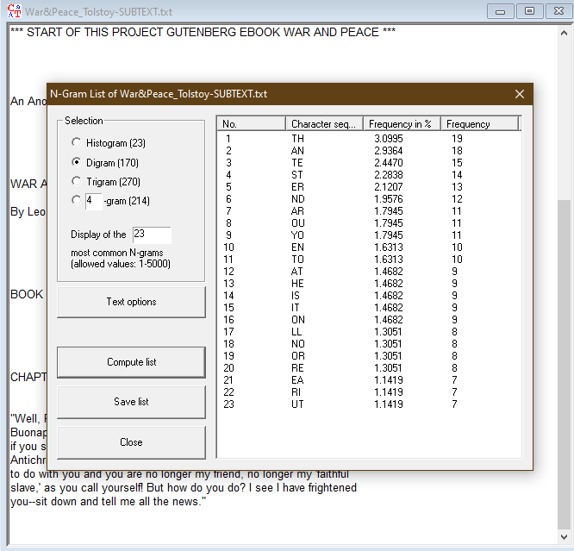

**The frequency diagram shows the most frequent characters for example I see that TH was used 19 times, AN was used 18 times and TE 15 times these were the top three most common.**

* (1.5 points for a NYT article) Summarize your observation of the frequency distribution. Also, provide a screenshot of the frequency distribution.

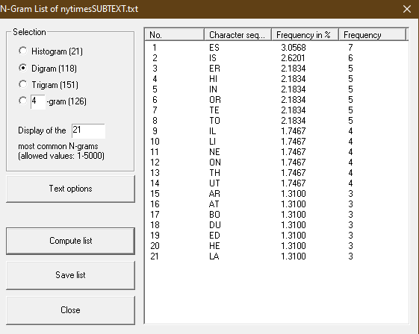

**The frequency diagram shows the most frequent characters for example in the N-Gram it displays that ES was used 7 times, IS was used 6 times and ER 5 times these were the top three most common.**

* (1 point) Compare and contrast the two frequency distributions.

Each has its own top frequency, NYTimes text file did not have as frequent repetitive letters as the War&Peace text file.

## Task 4 (4 points)

* (2 points) Attach a screen shot that shows the successful creation of the key pair.

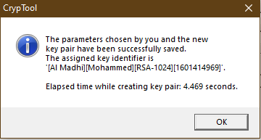

* (2 points) Attach a screenshot that displays the signature verification.

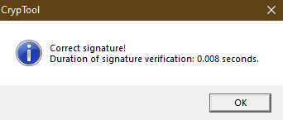

## Task 5 (4 points)

* (2 points) Follow the steps in the video and show the recovered secret text file as below.

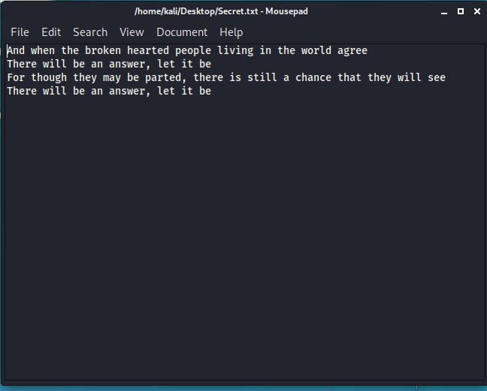

* (2 points) Show in screenshots that the contents of the two files are the same.

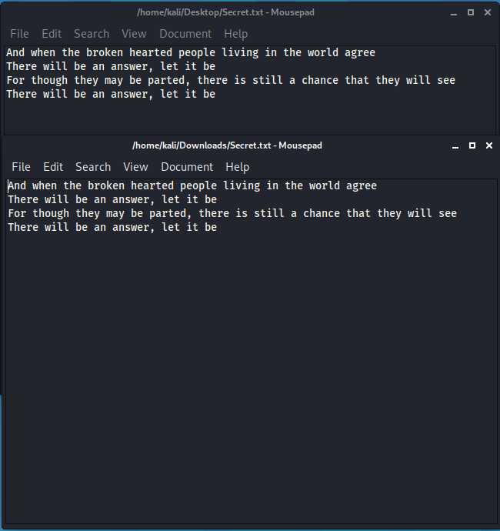

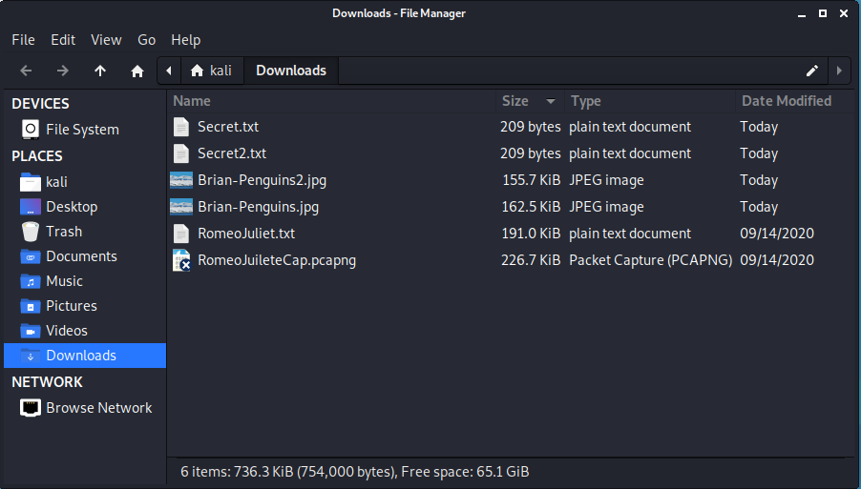

|  |  |
| --- | --- |
| The image of the original file | The image of the recovered file |
| Show the content here Face with Medical Mask on JoyPixels 6.0 | Show the content here Face with Medical Mask on JoyPixels 6.0 |